Pete’s F16 Pit

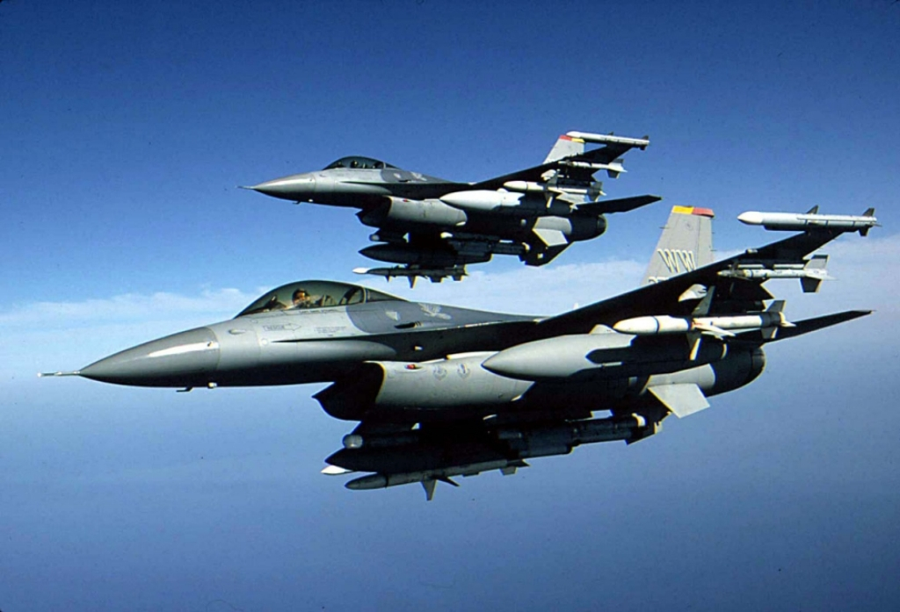

Test
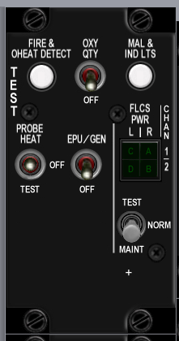
Build Status
Panel Purchased
Back Panel Purchased
Mounted in Pit
Backlighting | Ordered
Wired
Knobs mounted
Inputs Tested
Outputs Tested
Protective Coat Applied

 | Poles | Switch type | Positions
EPU GEN | 2 | toggle | off-on
PROBE HEAT | 3 | toggle | on-off-on
FIRE & OHEAT DETECT | 2 | push | off-(on)
OXY | 2 | toggle | off-on
MAL & IND LTS | 2
A B C D | 0 | indicator light | none
TEST MAINT | 3 | locking toggle | on-off-on

Notes:
Consider hard wiring indicators to on when power is available.

Anti-G

Build Status
Panel Purchased
Back Panel Purchased
Mounted in Pit
Wired
Knobs mounted
Inputs Tested
Outputs Tested

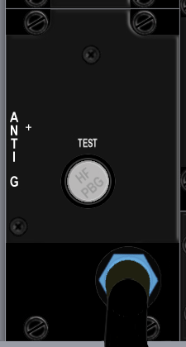

Switch Name | Poles | Switch type | Positions | Postion names | Notes | Callback
test | 2 | push | off-(on) | Test

Flt control
Build Status
Panel Purchased
Back Panel Purchased
Mounted in Pit
Wired
Knobs mounted
Inputs Tested
Outputs Tested

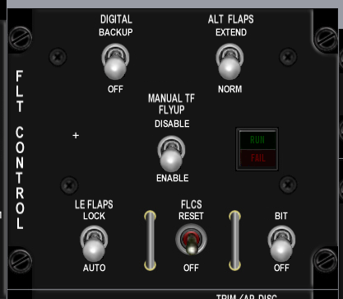

Switch Name | Poles | Switch type | Positions
DIGITAL | 2 | locking toggle | [off]-[on]
ALT FALPS | 2 | locking toggle | [off]-[on]
MANUAL TF FLYUP | 2 | locking toggle | [off]-[on]
LE FLAPS | 2 | locking toggle | [off]-[on]
FLCS | 2 | momentary toggle | (on)-off
BIT / OFF | 2 | locking toggle | [off]-[on]
RUN FAIL | 0 | indicator light | none

 | J4
1 | BKLGT-V
2 | BKLGT+V
3 | +12V LEFT
4 | +28V LEFT
5 | GND LEFT
6 | L_FLT
7 | FLP_EXT
8 | LEF_LCK
9 | 9 OPEN
10 | 10 OPEN

Manual Trim

Build Status
Panel Purchased
Back Panel Purchased
Mounted in Pit
Wired
Knobs mounted
Inputs Tested
Outputs Tested

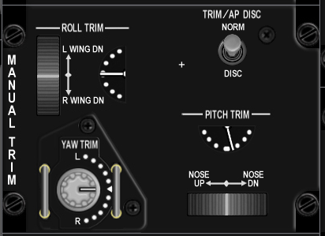

Switch Name | Poles | Call Back | Pole Totals | Switch type | Positions | Position names | Notes | Callback
 |  |  | 1
Pitch Trim | 1 | 0 | 0 | encoder with center detent | thumbwheel |  | light stripe showing position | BMS analog axis or SimTrimNoseUp, SimTrimNoseDown
Roll Trim | 1 | 0 | 0 | encoder with center detent | thumbwheel |  | light stripe showing position | BMS analog axis or SimTrimRollLeft, SimTrimRollRight
Yaw Trim | 1 | 0 | 0 | encoder with center detent | thumbwheel |  | light stripe showing position | BMS analog axis or SimTrimYawLeft, SimTrimYawRight
Trim /AP DISC | 2 | 1 | 1 | locking toggle | [off]-[on] | norm, disc |  | SimTrimAPNORM, SimTrimAPDISC

 | J30
1 | BKLGT-V
2 | BKLGT+V
3 | +12V LEFT
4 | +28V LEFT
5 | GND LEFT
6 | ROLL
7 | PITCH
8 | 8 OPEN,
9 | ANA_PWR
10 | ANA_GND
11 | APITCH
12 | AROLL
13 | AYAW
14 | YLEFT
15 | YRGHT
16 | RLEFT
17 | RRIGHT
18 | NSEUP
19 | NSEDWN
20 | AP_DISC

Fuel
Build Status
Panel Purchased
Back Panel Purchased
Mounted in Pit
Wired
Knobs mounted
Inputs Tested
Outputs Tested

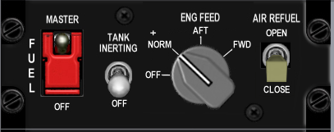

Switch Name | Poles | Switch type | Positions | Position names | Notes | Callback
MASTER | 2 | guarded toggle | off-on | OFF, MASTER | Guarded in MASTER | SimMasterFuelOff, SimMasterFuelOn
TANK INERTING | 2 | toggle | off-on | OFF-TANK INERTING ??????
ENG FEED | 4 | rotary knob | on-on-on-on | OFF, NORM, AFT, FWD | (4x45 deg) | SimFuelPumpOff, SimFuelPumpNorm, SimFuelPumpAft, SimFuelPumpFwd
AIR REFUEL | 2 | toggle | off-on | CLOSE, OPEN |  | SimFuelDoorOpen, SimFuelDoorClose?

 | J6
1 | BKLGT-V
2 | BKLGT+V
3 | +12V LEFT
4 | +28V LEFT
5 | GND LEFT
6 | FUEL_ON
7 | PMP_OFF
8 | PMP_NRM
9 | PMP_AFT
10 | PMP_FWD
11 | FUL_DOR
12 | 12 OPEN,
13 | 13 OPEN,
14 | 14 OPEN,
15 | 15 OPEN,
16 | 16 OPEN

Aux Comm

Build Status
Panel Purchased
Back Panel Purchased
Mounted in Pit
Wired
Knobs mounted
Inputs Tested
Outputs Tested

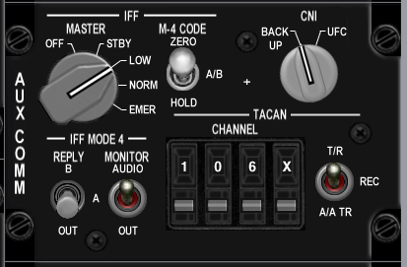

Switch Name | Poles | Switch type | Positions | Position names | Notes | Callback
MASTER | 5 | Rotary knob | on-on-on-on-on | off, STBY, LOW, NORM, EMER | (5x36 deg) | SimToggleAuxComMaster
M-4 CODE | 3 | locking toggle | [on]-[off]-[on] | hold, a/b, zero
CNI | 2 | Rotary knob | on-off | BACK UP, UFC | (2x36 deg) | SimAuxComBackup, SimAuxComUFC
REPLY | 3 | locking toggle | [off]-[on]-[on] | OUT, A, B
MONITOR | 2 | toggle | off-on | OUT, AUDIO
TACAN | 3 | toggle | on-off-on | A/A TR-REC-T/R |  | SimTACANAATR, SimTACANTR
CHANNEL 100's | 10 | encoder | cw/ccw | 0-9 inclusive |  | SimCycleLeftAuxComDigit, SimDecLeftAuxComDigit
CHANNEL 10's | 10 | encoder | cw/ccw | 0-9 inclusive |  | SimCycleCenterAuxComDigit, SimDecCenterAuxComDigit
CHANNEL 1's | 10 | encoder | cw/ccw | 0-9 inclusive |  | SimCycleRightAuxComDigit, SimDecRightAuxComDigit
channel x/y | 2 | encoder | cw/ccw | x, y |  | SimCycleBandAuxComDigit

 | J7
1 | BKLGT-V
2 | BKLGT+V
3 | +12V LEFT
4 | +28V LEFT
5 | GND LEFT
6 | COM_OFF
7 | COM_STB
8 | COM_LOW
9 | COM_NO
10 | COM_BCK
11 | COM_UFC
12 | TCN_ATR
13 | TCN_NTR
14 | 14 OPEN,
15 | 15 OPEN,
16 | 16 OPEN

 | J8
1 | BKLGT-V
2 | BKLGT+V
3 | +12V LEFT
4 | +28V LEFT
5 | GND LEFT
6 | R_GND
7 | INC_LFT
8 | DEC_LFT
9 | INC_CEN
10 | DEC_CEN
11 | INC_RGHT
12 | DEC_RGHT
13 | INC_BND
14 | DEC_BND
15 | 15 OPEN,
16 | 16 OPEN

Ext Lighting

Build Status
Panel Purchased
Back Panel Purchased
Mounted in Pit
Wired
Knobs mounted
Inputs Tested
Outputs Tested

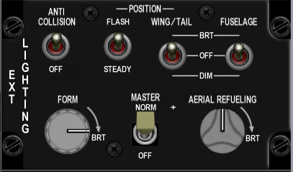

Switch Name | Poles | Switch type | Positions | Position names | Notes
Form | 0 | potentiometer | increase clockwise
Master | 2 | toggle | [off]-[on] | off, norm | SimExtlMasterOff, SimExtlMasterNorm
Aerial Refueling | 0 | potentiometer | increase clockwise
Anti Collision | 2 | toggle | off-on | off, anti collision | SimAntiCollOff, SimAntiCollOn
Flash Steady | 2 | toggle | on-off | flash, steady | SimLightsFlash, SimLightsSteady
Wing Trail | 3 | toggle | on-off-on | dim, off, brt | SimWingLightOff, SimWingLightBrt
Fuselage | 3 | toggle | on-off-on | dim, off, brt

 | J9
1 | BKLGT-V
2 | BKLGT+V
3 | +12V LEFT
4 | +28V LEFT
5 | GND LEFT
6 | EXTM_ON
7 | ACOL_ON
8 | FLSH_ON
9 | WNG_DM
10 | WNG_BRT
11 | P_MSTR
12 | P_DIM
13 | P_CMN
14 | 14 OPEN,
15 | 15 OPEN,
16 | 16 OPEN

EPU
Build Status
Panel Purchased
Back Panel Purchased
Mounted in Pit
Wired
Knobs mounted
Inputs Tested
Outputs Tested

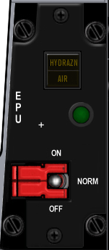

Switch Name | Poles | Switch type | Positions | Position names | Notes | Callback | Lightbits1 | Lightbits2
EPU | 3 | guarded toggle | off-on-on | OFF-NORMAL-ON | Center guard on NORMAL | SimEpuOff,SimEpuAuto,SimEpuOn
RUN light | 0 | indicator light | none | green light |  |  |  | EPUOn = $100000
HYDRAZN-AIR | 0 | indicator light | none | HYDRAZN-AIR |  |  |  | Hydrazine = $100,Air = $200

 | J10
1 | BKLGT-V
2 | BKLGT+V
3 | +12V LEFT
4 | +28V LEFT
5 | GND LEFT
6 | EPU_ON
7 | HYDRA
8 | AIR
9 | EPU_OF
10 | EPU_ON

Elect
Build Status
Panel Purchased
Back Panel Purchased
Mounted in Pit
Wired
Knobs mounted
Inputs Tested
Outputs Tested

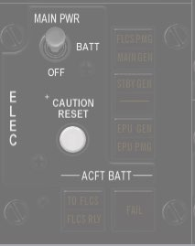

Switch Name | Poles | Switch type | Positions | Position names | Notes | Callback | Lightbits1 | Lightbits2
MAIN PWR | 3 | Locking toggle | [off]-[on]-[on] | OFF, BAT, MAIN PWR |  | SimMainPowerOff,SimMainPowerBatt,SimMainPowerMain
CAUTION RESET | 2 | push | off-(on) |  |  | SimWarnReset?
FLCS PMG-MAIN GEN | 0 | indicator light | none | FLCS PMG-MAIN GEN |  |  |  | FlcsPmg = $1,MainGen = $2
STBY GEN | 0 | indicator light | none | STBY GEN |  |  |  | StbyGen = $4
EPU GEN-EPU / PMG | 0 | indicator light | none | EPU GEN-EPU / PMG |  |  |  | EpuGen = $8,EpuPmg = $10
FAIL | 0 | indicator light | none | FAIL |  |  |  | BatFail = $80
TO FLCS-FLCS RLY | 0 | indicator light | none | TO FLCS-FLCS RLY |  |  |  | ToFlcs = $20,FlcsRly = $40

 | J17
1 | BKLGT-V
2 | BKLGT+V
3 | +12V LEFT
4 | +28V LEFT
5 | GND LEFT
6 | FLCSPMG
7 | MAINGEN
8 | STBYGEN
9 | EPUGEN
10 | EPUPMG
11 | BATFAIL
12 | TOFLCS
13 | FLCSRLY
14 | PWR_OFF
15 | PWRMAIN
16 | WRN_RST

AVTR

Build Status
Panel Purchased
Back Panel Purchased
Mounted in Pit
Wired
Knobs mounted
Inputs Tested
Outputs Tested

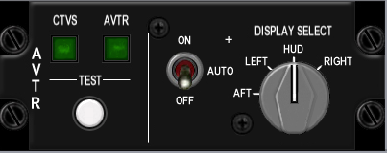

Switch Name | Poles | Switch type | Positions | Position names | Notes | Callback | Lightbits1 | Lightbits2 | Lightbits3 | HSIbits
AVTR | 3 | toggle | on-off-on | on, auto, off |  | SimAVTRSwitchOff, SimAVTRSwitchAuto, SimAVTRSwitchOn
 |  |  |  |  | (4x45 deg) |  |  |  |  | AVTR = $2000

 | J16
1 | BKLGT-V
2 | BKLGT+V
3 | +12V LEFT
4 | +28V LEFT
5 | GND LEFT
6 | AVTR
7 | AVT_OFF
8 | AVT_ON
9 | 9 OPEN
10 | 10 OPEN

ECM

Build Status
Panel Purchased
Back Panel Purchased
Mounted in Pit
Wired
Knobs mounted
Inputs Tested
Outputs Tested

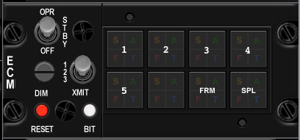

Switch Name | Poles | Switch type | Positions | Position names
OPR | 3 | toggle | off-on-on | OFF-STBY-OPR
DIM | 3 | rotary | on-on-on | 1, 2, 3
XMIT | 2 | locking toggle | [on]-[off] | xmit, blank
RESET | 2 | toggle | (on)-off | reset, blank
BIT | 2 | toggle | (on)-off | bit, blank
1 | 0 | indicator light | none | S, A, F, T light in corners
2 | 0 | indicator light | none | S, A, F, T light in corners
3 | 0 | indicator light | none | S, A, F, T light in corners
4 | 0 | indicator light | none | S, A, F, T light in corners
5 | 0 | indicator light | none | S, A, F, T light in corners
ALT | 0 | indicator light | none | S, A, F, T light in corners
FRM | 0 | indicator light | none | S, A, F, T light in corners
SPL | 0 | indicator light | none | S, A, F, T light in corners

Jet Start

Build Status
Panel Purchased
Back Panel Purchased
Mounted in Pit
Wired
Knobs mounted
Inputs Tested
Outputs Tested

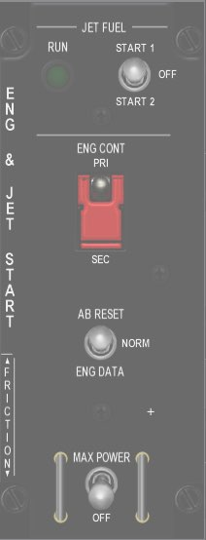

Switch Name | Poles | Switch type | Positions | Position names | Callback | Notes | Lightbits2
JET FUEL | 3 | locking toggle | [on]-[off]-[on] | START2-OFF-START1 | SimJFSStart | solenoid pulls to center after start ??
ENG CONT | 2 | guarded toggle | off-on | SEC-PRI |  | guarded up to PRI
AB RESET | 3 | toggle | (on)-off-(on) | ENG DATA-NORM-AB DATA
MAX POWER | 2 | locking toggle | [off]-(on) | OFF-MAX POWER
RUN | 0 | indicator light | none | green light |  |  | JFSOn = $200000

 | J13
1 | BKLGT-V
2 | BKLGT+V
3 | +12V LEFT
4 | +28V LEFT
5 | GND LEFT
6 | JFS_ON_LGHT
7 | JFS_ON_SOL
8 | JFS_ST
9 | 9 OPEN,
10 | 10 OPEN

Audio2

Build Status
Panel Purchased
Back Panel Purchased
Mounted in Pit
Wired
Knobs mounted
Inputs Tested
Outputs Tested

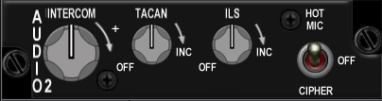

Switch Name | Poles | Switch type | Positions | Position names | Notes
INTERCOM | 0 | potentiometer | increase clockwise
TACAN | 2 | potentiometer 10k log | [off]-increase clockwise |  | rotary pot with off switch
ILS | 2 | potentiometer 10k log | [off]-increase clockwise |  | rotary pot with off switch
HOT MIC | 3 | toggle | on-off-on | CIPHER, OFF, HOT MIC

Audio

Build Status
Panel Purchased
Back Panel Purchased
Mounted in Pit
Wired
Knobs mounted
Inputs Tested
Outputs Tested

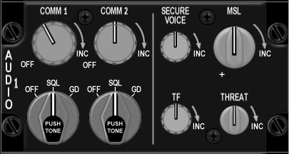

Switch Name | Poles | Switch type | Positions | Position names | Notes | Callback
COMM 1 volume | 2 | potetiometer | off-increase clockwise |  | rotary pot with off switch | BMS analog axis or SimStepComm1VolumeDown, SimStepComm1VolumeUp
COMM 1 selector | 3 | rotary knob | on-on-on | OFF-SQL-GD | PUSH FOR TONE,(3x45 deg)
COMM 2 volume | 2 | potetiometer | off-increase clockwise |  | rotary pot with off switch | BMS analog axis or SimStepComm2VolumeDown, SimStepComm2VolumeUp
COMM 2 selector | 3 | rotary knob | on-on-on | OFF-SQL-GD | PUSH FOR TONE,(3x45 deg)
SECURE VOICE | 0 | potetiometer | increase clockwise
TF | 0 | potetiometer | increase clockwise
MSL | 0 | potetiometer | increase clockwise |  |  | BMS analog axis or SimStepMissileVolumeDown, SimStepMissileVolumeUp
THREAT | 0 | potetiometer | increase clockwise |  |  | BMS analog axis or SimStepThreatVolumeDown, SimStepThreatVolumeUp

 | J31
1 | BKLGT-V
2 | BKLGT+V
3 | +12V LEFT
4 | +28V LEFT
5 | GND LEFT
6 | ANA_PWR
7 | ANA_GND
8 | ACM1_V
9 | ACM2_V
0 | AMSL_V
1 | ATHRT_V
2 | CM1_UP
3 | CM1_DWN
4 | CM2_UP
5 | CM2_DWN
6 | MSL_UP
7 | MSL_DWN
8 | THRT_UP
9 | THRT_DWN
20 | R_GND

UHF
Build Status
Panel Purchased
Back Panel Purchased
Mounted in Pit
Wired
Knobs mounted
Inputs Tested
Outputs Tested

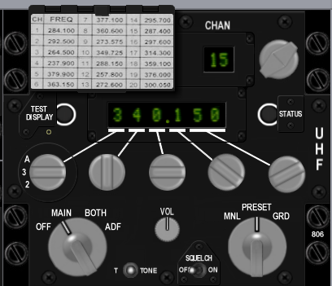

Switch Name | Poles | Switch type | Positions | Position names | Notes | Callback
UHF | 4 | rotary | on-on-on-on | OFF-MAIN-BOTH-ADF
TONE | 2 | push | off-(on) | tone
VOL | 0 | potentiometer | clockwise to increase
SQUELCH | 2 | toggle | off-on | OFF-ON
MANUAL | 3 | rotary | on-on-on | MANUAL-PRESET-GUARD
Freq 100's | 4 | encoder | cw-ccw | A, 3, 2, T
Freq 10's | 10 | encoder | cw-ccw | 0-9 inclusive
Freq 1's | 10 | encoder | cw-ccw | 0-9 inclusive
Freq 1/10's | 10 | encoder | cw-ccw | 0-9 inclusive
Freq 1/1000's | 4 | encoder | cw-ccw | 00, 25, 50, 75
CHAN | 20 | encoder | cw-ccw | 1-19 inclusive |  | SimCycleRadioChannel, SimDecRadioChannel
EMB | 2 | push | off-(on) | ??

Manual Pitch
Build Status
Panel Purchased
Back Panel Purchased
Mounted in Pit
Wired
Knobs mounted
Inputs Tested
Outputs Tested

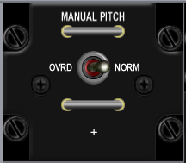

Switch Name | Poles | Switch type | Positions | Position names | Notes | Callback
MANUAL PITCH | 2 | toggle | off-on | OVRD-NORM | Horizontal wire guard loops above and below toggle | SimMPO

 | J3
1 | BKLGT-V
2 | BKLGT+V
3 | +12V LEFT
4 | +28V LEFT,
5 | GND LEFT
6 | MPTCHO NET49_1,
7 | 7 OPEN,
8 | 8 OPEN,
9 | 9 OPEN,
10 | 10 OPEN

Threat Warn Aux
Build Status
Panel Purchased
Back Panel Purchased
Mounted in Pit
Wired
Knobs mounted
Inputs Tested
Outputs Tested

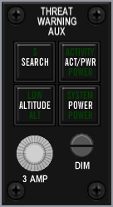

Switch Name | Poles | Switch type | Positions | Position names | Notes | Callback | Lightbits1 | Lightbits2
Search | 2 | on/off lighted push | off-on | search |  | SimRWRSetSearch |  | AuxSrch = $1000
activity power | 2 | on/off lighted push | off-on | activity power |  |  |  | AuxAct = $2000
Low priority | 2 | on/off lighted push | off-on | low |  | SimRWRSetGroundPriority? |  | AuxLow = $4000
system power | 2 | on/off lighted push | off-on | power |  | SimRwrPower |  | AuxPwr = $8000
fuse | 0 | fuse holder | none | n/a
Dimmer | 0 | potentiometer | rotary | n/a | no EPIC connection

 | J22
1 | BKLGT-V
2 | BKLGT+V
3 | +12V LEFT
4 | +28V LEFT
5 | GND LEFT
6 | AXSCH
7 | AXACT
8 | AXLOW
9 | AXPWR
10 | R_SRCH
11 | R_GND
12 | R_PWR
13 | 13 OPEN,
14 | 14 OPEN,
15 | 15 OPEN,
16 | 16 OPEN

CMDS
Build Status
Panel Purchased
Back Panel Purchased
Mounted in Pit
Wired
Knobs mounted
Inputs Tested
Outputs Tested

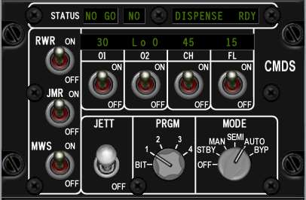

Switch Name | Poles | Switch type | Positions | Position names | Notes | Callback
RWR | 2 | toggle | off-on | off, on |  | SimEWSRWROn, SimEWSRWROff
JMR | 2 | toggle | off-on | off, on |  | SimEWSJammerOn, SimEWSJammerOff
MWS | 2 | toggle | off-on | off, on
01 | 2 | toggle | off-on | off, on
02 | 2 | toggle | off-on | off, on
CH | 2 | toggle | off-on | off, on |  | SimEWSChaffOff, SimEWSChaffOn
FL | 2 | toggle | off-on | off, on |  | SimEWSFlareOff, SimEWSFlareOn
JETT | 2 | locking toggle | off-on | off, JETT
PRGM | 5 | rotary | on-on-on-on-on | bit, 1, 2, 3, 4, 5 | (5x36 deg) | SimEWSProgOne, SimEWSProgTwo, SimEWSProgThree, SimEWSProgFour
MODE | 6 | rotary | on-on-on-on-on-on | off, stby, man, semi, auto, byp | (6x30 deg) | SimEWSModeOff, SimEWSModeStby, SimEWSModeMan, SimEWSModeSemi, SimEWSModeAuto,
STATUS NO GO | 0 | green indicator light | n/a | NO GO (green lit legend)
STATUS GO | 0 | green indicator light | n/a | GO (green lit legend)
STATUS READY | 0 | green indicator light | n/a | READY TO DISPENSE (green lit legend)

 | J21
1 | BKLGT-V
2 | BKLGT+V
3 | +12V LEFT
4 | +28V LEFT
5 | GND LEFT
6 | GO NET5_2,
7 | NO_GO
8 | RDY_DISP
9 | CHAFF_LO
10 | FLARE_LO

 | J23
1 | BKLGT-V
2 | BKLGT+V
3 | +12V LEFT
4 | +28V LEFT
5 | GND LEFT
6 | RWR_ON
7 | JMR_ON
8 | CHF_ON
9 | FLR_ON
10 | PRG_BIT
11 | PRG_1
12 | PRG_2
13 | PRG_3
14 | PRG_4
15 | MDEOFF
16 | MDESTBY
17 | MDEMAN
18 | MDESEMI
19 | MDEAUTO
20 | MDEBYP

Gear Panel
Build Status
Panel Purchased
Back Panel Purchased
Mounted in Pit
Wired
Knobs mounted
Inputs Tested
Outputs Tested

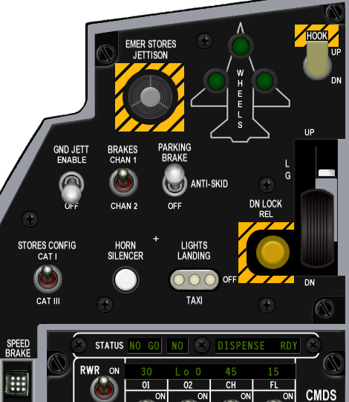

Switch Name | Poles | Switch type | Positions | Position names | Notes | Callback | Lightbits1 | Lightbits2 | Lightbits3
Emergency jettison | 2 | guarded push | off-(on) | n/a | breakable cover over | SimEmergencyJettison
wheel lights | 0 | 3 x green lights | none | n/a |  |  |  |  | NoseGearDown = $10000,LeftGearDown = $20000,RightGearDown = $40000
Hook | 2 | lever locking toggle | [off]-[on] | dn, up |  | SimHookUp,SimHookDown
Ground jettison | 2 | locking toggle | [off]-[on] | off, enable |  | SimGndJettOn, SimGndJettOff
Brakes | 2 | toggle | off-on | chan 2, chan 1
Parking brake | 3 | locking toggle | [off]-[on]-[on] | off, anti skid, brake |  | SimParkingBrakeOff, ,SimParkingBrakeOn
Stores | 2 | toggle | off-on | cat III, cat I |  | SimCATIII,SimCATI
Horn silencer | 2 | push | off-(on) | n/a |  | SimSilenceHorn
Landing lights | 3 | locking t handle toggle | [on]-[off]-[on] | taxi, off, landing |  | SimLandingLightOn, SimLandingLightOff
Down lock release | 2 | push | off-(on) | n/a
Gear down enable | 2 | push | off-(on) | n/a | mounted on the arm of the gear handle
Gear handle | 2 | lollipop lever | off-on | (down and up) |  | AFGeapUp, AFGearDown
Gear warning light | 0 | yellow light | none | n/a | mounted in lollipop end of the gear handle |  |  | GEARHANDLE = $40000000

 | J29
1 | BKLGT-V
2 | BKLGT+V
3 | +12V LEFT
4 | +28V LEFT
5 | GND LEFT
6 | N_GEAR
7 | L_GEAR
8 | R_GEAR
9 | G_HNDLE
10 | PK_SOLND
11 | HOOK
12 | GNDJETT
13 | PARKBRK
14 | EMG_JET
15 | CAT_III
16 | L_TAXI
17 | L_LAND
18 | L_GEAR
19 | HRN_SIL
20 | 20 OPEN

MISC
Build Status
Panel Purchased
Back Panel Purchased
Mounted in Pit
Wired
Knobs mounted
Inputs Tested
Outputs Tested

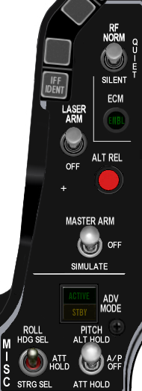

Switch Name | Poles | Switch type | Positions | Position names | Notes | Callback | Lightbits1 | Lightbits2
RF quiet | 3 | locking toggle | [on[-[off]-[on] | silent, rf norm |  | SimRFNorm, SimRFQuiet, SimRFSilent
ECM light | 0 | green light | none | n/a |  |  |  | EcmPwr = $10000?
Laser arm | 2 | locking toggle | [off]-[on] | off, arm |  | SimLaserArmOn, SimLaserArmOff
Alternate release | 2 | push | off-(on) | n/a |  | SimPickle
Master arm | 3 | locking toggle | [on]-[off]-[on] | simulate, off, arm |  | SimSimMasterArm, SimSafeMasterArm, SimArmMasterArm
ADV mode | 0 | indicator light tile | none | active/standby
Autopilot pitch | 3 | locking toggle | [on]-[off]-[on] | att hold, a-p off, alt hold |  | SimRightAPDown, SimRightAPMid, SimRightAPUp
Autopilot roll | 3 | toggle | on-off-on | strg sel, att hold, hdg sel |  | SimLeftAPDown, SimLeftAPMid, SimLeftAPUp

 | J17
1 | BKLGT-V
2 | BKLGT+V
3 | +12V
4 | +28V
5 | GND ,
6 | ECM_PWR
7 | AP_ON
8 | TFR_STDBY
9 | ECM_PWR
0 | TFR_ENGAGED
1 | RF_NRM
2 | RF_SILNT
3 | LSR_ON
4 | S_PICKLE
5 | MST_ARM
6 | MST_SIM
7 | RAP_DWN
8 | RAP_UP
9 | LAP_DWN
10 | LAP_UP

Threat Warn Prim
Build Status
Panel Purchased
Back Panel Purchased
Mounted in Pit
Wired
Knobs mounted
Inputs Tested
Outputs Tested

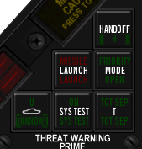

Switch Name | Poles | Switch type | Positions | Notes | Callback | Lightbits1 | Lightbits2
Handoff | 2 | push | off-(on) | Green illumination on push to select handoff mode | SimRWRHandoff |  | HandOff = $1
Priority | 2 | push | off-(on) | Green illumination on push to select priority threat mode | SimRWRSetPriority |  | PriMode = $4
Target separate | 2 | push | off-(on) | Green illumination on push to separate target symbols | SimRWRSetTargetSep |  | TgtSep = $20
Missile Launch | 0 | indicator light tile | none | Red light |  |  | Launch = $2
system test | 2 | push | off-(on) | Green light on push
Unknown/naval | 2 | push | off-(on) | Green light on push | SimRWRSetNaval, SimRWRSetUnknowns |  | Naval = $8,Unk = $10

 | 19
1 | BKLGT-V
2 | BKLGT+V
3 | +12V
4 | +28V
5 | GND ,
6 | HANDOFF
7 | PRIMODE
8 | TGTSEP
9 | LAUNCH
10 | NAVAL
11 | UKNOWN
12 | RHANDOFF
13 | RSETPRI
14 | RSETTGT
15 | RSETNVL
16 | RSETUN

Eyebrow Lights L
Build Status
Panel Purchased
Back Panel Purchased
Mounted in Pit
Wired
Knobs mounted
Inputs Tested
Outputs Tested

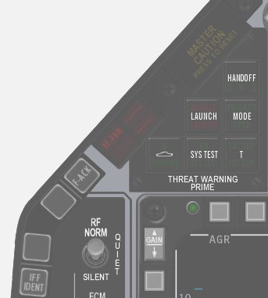

Switch Name | Poles | Switch type | Positions | Position names | Notes | Callback | Lightbits1
Left
IFF | 2 | push | off-(on) | IFF IDENT
Blank 1 | 2 | push | off-(on) | (directly above IFF button)
Blank 2 | 2 | push | off-(on) | (directly below TF-FAIL button)
TF fail | 0 | red indicator light | none | TF-FAIL | Red illumination, normally off |  | TF = $2
F-ACK | 2 | push | off-(on) | F-ACK |  | SimICPFAck
Master Caution | 2 | push | off-(on) | Master Caution push to reset |  | ExtinguishMasterCaution | MasterCaution = $1

 | J16
1 | BKLGT-V
2 | BKLGT+V
3 | +12V
4 | +28V
5 | GND ,
6 | TFF
7 | M_CAUT
8 | F_ACK
9 | EXT_CTN
10 | 10 OPEN

Eyebrow Lights R
Build Status
Panel Purchased
Back Panel Purchased
Mounted in Pit
Wired
Knobs mounted
Inputs Tested
Outputs Tested

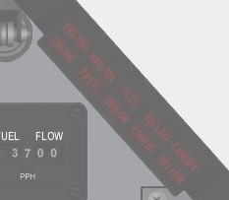

Switch Name | Poles | Switch type | Positions | Position names | Notes | Callback | Lightbits1
Right
Engine fire | 2 | push | off-(on) | ENGFIRE ENGINE | Red illumination, normally off |  | ENG_FIRE = $20, ENGINE=80000000
Fluid pressure warning | 2 | push | off-(on) | HYD/OIL PRESS | Red illumination, normally off |  | HYD = $80,  OIL = $100
Flight controls warning | 2 | push | off-(on) | FLCS DBU ON | Red illumination, normally off
Landing configuration | 2 | push | off-(on) | TO/LDG CONFIG | Red illumination, normally off |  | T_L_CFG = $800
Canopy seal warning | 2 | push | off-(on) | CANOPY | Red illumination, normally off |  | CAN = $400

 | J11
1 | BKLGT-V
2 | BKLGT+V
3 | +12V
4 | +28V
5 | GND ,
6 | E_FIRE
7 | ENGINE
8 | OIL
9 | TL_CFG
10 | CANOPY

A little challenge here as Leo provides support for more Light BITS, and Mike’s Right Eyebrow is different to what I’d been working off. Ended up using http://www.scribd.com/doc/903695/F16MLU-Checklist as a reference

 | Original | Mike | F4IM | F4IM Comments
Engine | 7 | Engine |  | ENG_FIRE | 6
E_Fire | 6 | Eng Fire |  | ENG_FIRE | 6
OIL | 8 | Press |  | OIL | 7
 |  | HYD/OIL |  | HYD | 8
 |  | FLCS |  | DUAL | 9
 |  | DBO ON |  | DUAL | 9
TL_CFG | 9 | TO/LDG |  | T_L_CFG | 10
 |  | CONFIG |  | CONFIG | 11
Canopy | 10 | CANOPY |  | CAN | 12
 |  | OXY LOW | N/A

As Wired
 |  | 1 | 2 | 3 | 4 | 5 | 6 | 7 | 8
ENG FIRE | 1 | X
ENGINE | 2 |  | X
PRESS | 3 |  |  | X
CONFIG | 4 |  |  |  | X
CANOPY | 5 |  |  |  |  | X
HYD/OIL | 6 |  |  | X
DBU ON | 7 |  |  |  |  |  | X
FLCS | 8 |  |  |  |  |  |  | X
TO/LDG | 9 |  |  |  | X
OXY LOW | 10 |  |  |  |  |  |  |  | X

ENG FIRE  1 | HYD/OIL  6 | FLCS  8 | TO/LDG  9 | CANOPY  5
ENGINE  2 | PRESS  3 | DBU ON  7 | CONFIG  4 | OXY LOE  10

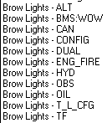

Final Wiring of Spare Connector
 | J32
1 | BKLGT-V
2 | BKLGT+V
3 | +12V
4 | +28V
5 | GND ,
6 | E_FIRE
7 | ENGINE
8 | OIL
9 | TL_CFG
10 | CANOPY
11 | FLCS
12 | DBU ON
13 | OXY LOW

Indexer L

Build Status
Panel Purchased
Back Panel Purchased
Mounted in Pit
Wired
Knobs mounted
Inputs Tested
Outputs Tested

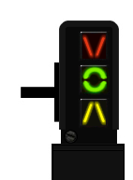

Switch Name | Poles | Switch type | Positions | Position names | Notes | Callback | Lightbits1
Left Indexer
 |  |  |  |  |  |  | AOAAbove = $1000
 |  |  |  |  |  |  | AOAOn = $2000
 |  |  |  |  |  |  | AOABelow = $4000

 | J8
1 | BKLGT-V
2 | BKLGT+V
3 | +12V
4 | +28V
5 | GND ,
6 | A_ABVE
7 | A_ON
8 | A_BLOW
9 | 9 OPEN,
10 | 10 OPEN

Indexer R

Build Status
Panel Purchased
Back Panel Purchased
Mounted in Pit
Wired
Knobs mounted
Inputs Tested
Outputs Tested

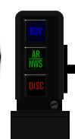

Switch Name | Poles | Switch type | Positions | Position names | Notes | Callback | Lightbits1
Right Indexer
 |  |  |  |  |  |  | RefuelRDY = $8000
 |  |  |  |  |  |  | RefuelAR = $10000
 |  |  |  |  |  |  | RefuelDSC = $20000

 | J9
1 | BKLGT-V
2 | BKLGT+V
3 | +12V
4 | +28V
5 | GND ,
6 | R_RDY NET41_2,
7 | R_AR NET40_2,
8 | R_DSC NET39_2,
9 | 9 OPEN,
10 | 10 OPEN

ICP

Build Status
Panel Purchased
Back Panel Purchased
Mounted in Pit
Wired
Knobs mounted
Inputs Tested
Outputs Tested

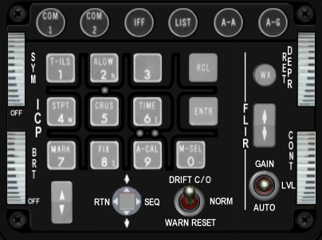

Switch Name | # of poles | Switch type | Positions | Position names | Notes | Callback
COM1 | 2 | push | off-(on) | n/a |  | SimICPCom1
COM2 | 2 | push | off-(on) | n/a |  | SimICPCom2
IFF | 2 | push | off-(on) | n/a |  | SimICPIFF
LIST | 2 | push | off-(on) | n/a |  | SimICPLIST
A-A | 2 | push | off-(on) | n/a |  | SimICPAA
A-G | 2 | push | off-(on) | n/a |  | SimICPAG
1 key | 2 | push tile | off-(on) | n/a |  | SimICPTILS
2 key | 2 | push tile | off-(on) | n/a |  | SimICPALOW
3 key | 2 | push tile | off-(on) | n/a |  | SimICPTHREE
Recall key | 2 | push tile | off-(on) | n/a |  | SimICPCLEAR
4 key | 2 | push tile | off-(on) | n/a |  | SimICPStpt
5 key | 2 | push tile | off-(on) | n/a |  | SimICPCrus
6 key | 2 | push tile | off-(on) | n/a |  | SimICPSIX
enter key | 2 | push tile | off-(on) | n/a |  | SimICPEnter
7 key | 2 | push tile | off-(on) | n/a |  | SimICPMark
8 key | 2 | push tile | off-(on) | n/a |  | SimICPEIGHT
9 key | 2 | push tile | off-(on) | n/a |  | SimICPNINE
0 key | 2 | push tile | off-(on) | n/a |  | SimICPZERO
WX | 2 | push | off-(on) | n/a
ICP inc/dec | 3 | rocker | (on)-off-(on) | down arrow, up arrow |  | SimICPNext, SimICPPrevious
display control switch | 4 | 4-way momentary bat | (on)-(on)-(on)-(on)-center off | down, rtn, up, seq (cw from bottom) | ? | SimICPDEDDOWN, SimICPResetDED ,SimICPDEDUP, SimICPDEDSEQ
Drift cutoff | 3 | toggle (momentary 1 side only) | (on)-off-on | warn reset, norm, drift c/o |  | SimDriftCOOff, SimDriftCOOn
FLIR up/down | 3 | rocker | (on)-off-(on) | down arrow, up arrow
FLIR gain | 3 | toggle | on-off-on | auto, lvl, gain
SYM | 2 | 10k linear pot | off-increase clockwise | off |  | BMS analog axis or SimSymWheelD <SimSymWheelUp
BRT | 0 | 10k linear pot | off-increase clockwise |  |  | BMS analog axis or SimHUDBrightnessDown, SimHUDBrightnessUp
 |  |  |  |  |  | SimHUDOn, SimHUDOff
RET DEPR | 0 | 10k linear pot | increase clockwise |  |  | BMS analog axis or SimRetDn,SimRetUp
CONT | 0 | 10k linear pot | increase clockwise

INSTR

Build Status
Panel Purchased
Back Panel Purchased
Mounted in Pit
Wired
Knobs mounted
Inputs Tested
Outputs Tested

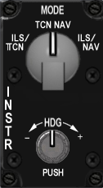

Switch Name | # of poles | Switch type | Positions | Postion names | Notes | Callback
mode | 4 | rotary | on-on-on-on | ils/tcn, tcn, nav, ils/nav | (4x30 deg) | SimHSIIlsTcn, SimHSITcn, SimHSINav, SimHSIIlsNav
heading | 0 | potentiometer | rotary | n/a | no EPIC connection

 | J4 | Implemented
1 | BKLGT-V | BKLGT-V
2 | BKLGT+V | BKLGT+V
3 | +12V | +12V
4 | +28V | +28V
5 | GND , | GND ,
6 | I_TCN | I_TCN
7 | TCN | TCN
8 | NAV | I_NAV
9 | I_NAV | OPEN
10 | 10 OPEN, | OPEN
11 | R_GND | R_GND
12 | R_CRSE_A | R_CRSE_HEAD_A
13 | R_CRSE_B | R_CRSE_HEAD_A
14 | R_HEAD_A | R_Pushed
15 | R_HEAD_B
16 | 16 OPEN

HIS – Not used

Build Status - not used
Panel Purchased
Back Panel Purchased
Mounted in Pit
Wired
Knobs mounted
Inputs Tested
Outputs Tested

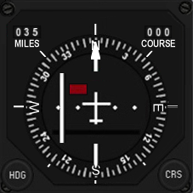

Switch Name | # of poles | Switch type | Positions | Postion names | Notes | Callback
course | 360 | encoder | rotary | n/a |  | SimHsiCourseDec, SimHsiCourseInc
heading | 360 | encoder | rotary | n/a |  | SimHsiHeadingDec, SimHsiHeadingInc

The Course and Heading input is mapped to a single rotary on the INSTR panel, with the role changing if the rotary is pushed while rotating.

Fuel Qty Select

Build Status
Panel Purchased
Back Panel Purchased
Mounted in Pit
Wired
Knobs mounted
Inputs Tested
Outputs Tested

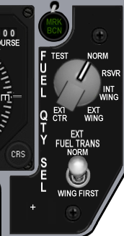

Switch Name | # of poles | Switch type | Positions | Postion names | Notes | Callback
source | 6 | rotary | on-on-on-on-on-on | ext ctr, ext wing, int wing, rsvr, norm, test | (6x45 deg) | SimFuelSwitchCenterExt, SimFuelSwitchWingExt, SimFuelSwitchWingInt, SimFuelSwitchResv, SimFuelSwitchNorm, SimFuelSwitchTest
Fuel transfer | 2 | locking toggle | [off]-[on] | wing first, norm |  | SimFuelTransWing,SimFuelTransNorm

 | J12
1 | BKLGT-V
2 | BKLGT+V
3 | +12V
4 | +28V
5 | GND ,
6 | MARKER
7 | EXT_WNG
8 | INT_WNG
9 | RVSR
10 | NORM
11 | TEST
12 | TRNSFR
13 | EXT_CTR
14 | INST_FLG1
15 | INST_FLG2
16 | INST_FLG3

Caution Panel

Build Status
Panel Purchased
Back Panel Purchased
Mounted in Pit
Wired
Knobs mounted
Inputs Tested
Outputs Tested

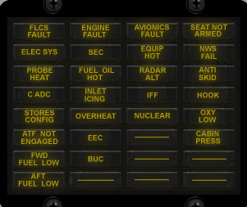

Lightbits1 | Lightbits2 | Lightbits3
CONFIG = $40
DUAL = $200;
FltControlSys = $40000
LEFlaps = $80000
EngineFault = $100000
Overheat = $200000
FuelLow = $400000
Avionics = $800000
RadarAlt = $1000000
IFF = $2000000
ECM = $4000000
Hook = $8000000
NWSFail = $10000000
CabinPress = $20000000
 | FwdFuelLow = $40000
 | AftFuelLow = $80000
 | SEC = $400000
 | OXY_LOW = $800000
 | PROBEHEAT = $1000000
 | SEAT_ARM = $2000000
 | BUC = $4000000
 | FUEL_OIL_HOT = $8000000
 | ANTI_SKID = $10000000
 |  | Elec_Fault = $400

Sensor Power

Build Status
Panel Purchased
Back Panel Purchased
Mounted in Pit
Wired
Knobs mounted
Inputs Tested
Outputs Tested

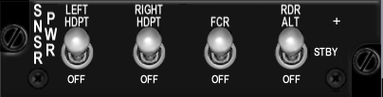

Switch Name | # of poles | Switch type | Positions | Postion names | Notes
Left hardpoint | 2 | toggle | off-on | off, left hdpt | SimLeftHptOff, SimLeftHptOn
Right hardpoint | 2 | toggle | off-on | off, right hdpt | SimRightHptOff, SimRightHptOn
Fire control radar | 2 | toggle | off-on | off, fcr | SimFCROff, SimFCROn
Radar altimeter | 3 | toggle | off-on-on | off, stby, rdr alt | SimRALTOFF, SimRALTSTDBY, SimRALTOFF

 | J23
1 | BKLGT-V
2 | BKLGT+V
3 | +12V
4 | +28V
5 | GND ,
6 | L_HPT
7 | R_HPT
8 | FCR
9 | RA_STD
10 | RA_ON

HUD Control

Build Status
Panel Purchased
Back Panel Purchased
Mounted in Pit
Wired
Knobs mounted
Inputs Tested
Outputs Tested

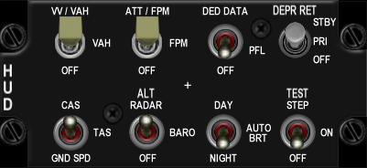

Switch Name | # of poles | Switch type | Positions | Postion names | Notes | Callback
Velocity scales | 3 | toggle | off-on-on | off, vah, vv/vah |  | SimScalesOff, SimScalesVAH, SimScalesVVVAH
Attitude scales | 3 | toggle | off-on-on | off, fpm, att/fpm |  | SimPitchLadderOff, SimPitchLadderFPM, SimPitchLadderATTFPM
Data Entry | 3 | toggle | off-on-on | off, pfl, ded data |  | SimHUDDEDOff, SimHUDDEDPFL, SimHUDDEDDED
DEPR reticle | 3 | toggle | [off]-[on]-[on] | off, pri, stby |  | SimReticleOff, SimReticlePri, SimReticleStby
Velocity | 3 | toggle | off-on-on | gnd spd, tas, cas |  | SimHUDVelocityGND, SimHUDVelocityTAS, SimHUDVelocityCAS
Altitude | 3 | toggle | off-on-on | auto, baro, alt radar |  | SimHUDAltAuto, SimHUDAltBaro, SimHUDAltRadar
Brightness | 3 | toggle | off-on-on | night, auto, day |  | SimHUDBrtNight, SimHUDBrtAuto, SimHUDBrtDay
Test | 3 | toggle | off-on-on | off, on, test step

1 | BKLGT-V
2 | BKLGT+V
3 | +12V
4 | +28V
5 | GND ,
6 | S_VA
7 | S_VV
8 | FPM
9 | AT_FPM
10 | PFL
11 | DED
12 | R_PRI
13 | R_STD
14 | A_BARO
15 | A_RDR
16 | NIGHT
17 | DAY
18 | CAS
19 | GNDSPD
20 | 20 OPEN

Nuclear consent

Build Status
Panel Purchased
Back Panel Purchased
Mounted in Pit
Wired
Knobs mounted
Inputs Tested
Outputs Tested

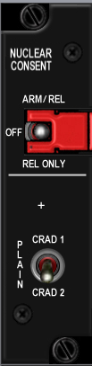

Switch Name | # of poles | Switch type | Positions | Postion names
plain | 2 | toggle | off-on | crad1, crad 2
arm | 3 | guarded toggle | on-off-on | rel only, off, arm rel

Lighting

Build Status
Panel Purchased
Back Panel Purchased
Mounted in Pit
Wired
Knobs mounted
Inputs Tested
Outputs Tested

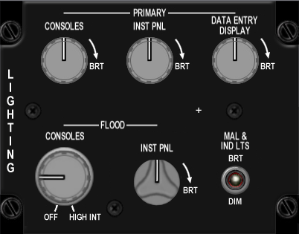

Switch Name | # of poles | Switch type | Positions | Postion names
Consoles (primary) | 0 | potentiometer | increase clockwise
instrument panel (primary) | 0 | potentiometer | increase clockwise
Data entry display (primary) | 0 | potentiometer | increase clockwise
Consoles (flood) | 2 | off-potentiometer | increase clockwise
instrument panel (flood) | 0 | potentiometer | increase clockwise
malfunction lights | 2 | toggle | off-on | dim, brt

 | J27
1 | BKLGT-V
2 | BKLGT+V
3 | +12V
4 | +28V
5 | GND ,
6 | POT_GND POT_GROUND_4,
7 | POT_+V POT_+V_4,
8 | POT_1 POT_1_4,
9 | POT_2 POT_2_4,
10 | POT_3 POT_3_4,
11 | POT_4 POT_4_4,
12 | DIM_BRIGHT DIM_BRIGHT_4,
13 | 13 OPEN,
14 | 14 OPEN,
15 | 15 OPEN,
16 | 16 OPEN

Master Zeroize
Build Status
Panel Purchased
Back Panel Purchased
Mounted in Pit
Wired
Knobs mounted
Inputs Tested
Outputs Tested

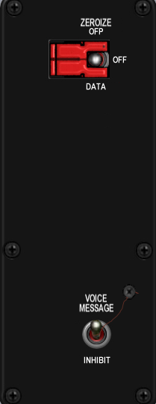

Switch Name | # of poles | Switch type | Positions | Postion names | Notes | Callback
voice message | 2 | toggle | off-on | inhibit, voice message |  | SimVMSOFF, SimVMSOn
zeroize | 3 | guarded toggle | on-off-on | data zeroize, blank, master zeroize | guarded in center off position

 | J33
1 | BKLGT-V
2 | BKLGT+V
3 | +12V
4 | +28V
5 | GND ,
6 | V_INHB NET5_5,
7 | 7 OPEN,
8 | 8 OPEN,
9 | 9 OPEN,
10 | 10 OPEN

Air Cond

Build Status
Panel Purchased
Back Panel Purchased
Mounted in Pit
Wired
Knobs mounted
Inputs Tested
Outputs Tested

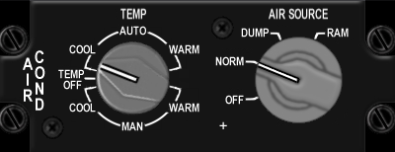

Switch Name | # of poles | Switch type | Positions | Postion names | Notes | Callback
air source | 4 | rotary | on-on-on-on | off, norm, dump, ram | (4x45 deg) | SimAirSourceOff, SimAirSourceNorm, SimAirSourceDump, SimAirSourceRam
temp | 7 | rotary | on-on-on-off-on-on-on |  | No EPIC connection

 | J34
1 | BKLGT-V
2 | BKLGT+V
3 | +12V
4 | +28V
5 | GND ,
6 | OFF
7 | NORM
8 | DUMP
9 | RAM
10 | 10 OPEN

KY-58

Build Status
Panel Purchased
Back Panel Purchased
Mounted in Pit
Wired
Knobs mounted
Inputs Tested
Outputs Tested

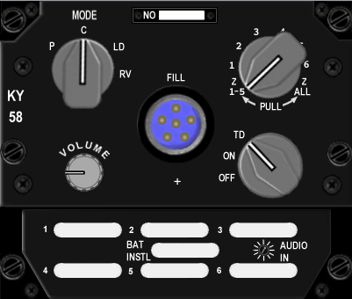

Switch Name | # of poles | Switch type | Positions | Postion names | Notes
mode | 4 | rotary knob | on-on-on-on | p, c, ld, rv | (4x45 deg)
volume | 0 | 10k log potentiometer | clockwise to increase |  | no EPIC connection
number rotary | 8 | rotary knob | {on}-on-on-on-on-on-on-{on} | 215, 1, 2, 3, 4, 5, 6, 7 all | (8x30 deg)
on/off rotary | 3 | rotary knob | on-on-on | off, on, TD | (3x30 deg)

Avionics Power

Build Status
Panel Purchased
Back Panel Purchased
Mounted in Pit
Wired
Knobs mounted
Inputs Tested
Outputs Tested

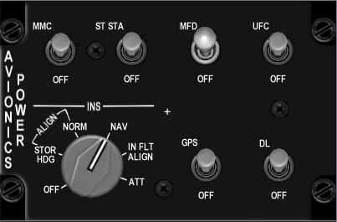

Switch Name | # of poles | Switch type | Positions | Postion names | Notes | Callback
FCC | 2 | Locking toggle | [off]-[on] | off, FCC |  | SimFCCOff, SimFCCOn
SMS | 2 | Locking toggle | [off]-[on] | off, SMS |  | SimSMSOff, SimSMSOn
MFD | 2 | Locking toggle | [off]-[on] | off, MFD |  | SimMFDOff, SimMFDOn
UFC | 2 | Locking toggle | [off]-[on] | off, UFC |  | SimUFCOff, SimUFCOn
INS | 7 | Rotary knob | on-on-on-on-on-on-on | off, stor hdg, norm, nav, cal, in flt align, att | (7x45deg) | SimINSOff, SimINSNorm, SimINSNav, SimINSInFlt
GPS | 2 | Locking toggle | [off]-[on] | off, GPS |  | SimGPSOff, SimGPSOn
DL | 2 | Locking toggle | [off]-[on] | off, DL |  | SimDLOff, SimDLOn
MAP | 2 | Locking toggle | [off]-[on] | off, MAP |  | SimMAPOff, SimMAPOn

 | J24
1 | BKLGT-V
2 | BKLGT+V
3 | +12V
4 | +28V
5 | GND ,
6 | FCC
7 | SMS
8 | MFD
9 | UFC
10 | I_OFF
11 | I_HDG
12 | I_NRM
13 | I_NAV
14 | I_CAL
15 | I_ATT
16 | GPS
17 | TISL
18 | MAP
19 | P_GND PHY_MFD_PWR_4,
20 | P_MFD_PWR PHY_GND_4

Anti-Ice

Build Status
Panel Purchased
Back Panel Purchased
Mounted in Pit
Wired
Knobs mounted
Inputs Tested
Outputs Tested

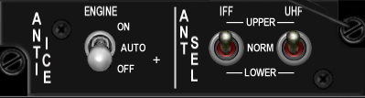

Switch Name | # of poles | Switch type | Positions | Postion names | Notes | Callback
engine anti ice | 3 | locking toggle | [off]-[on]-[on] | off, auto, on
IFF antenna select | 3 | toggle | on-off-on | lower, norm, upper
UHF antenna select | 3 | toggle | on-off-on | lower, norm, upper

Oxy Reg

Build Status
Panel Purchased
Back Panel Purchased
Mounted in Pit
Wired
Knobs mounted
Inputs Tested
Outputs Tested

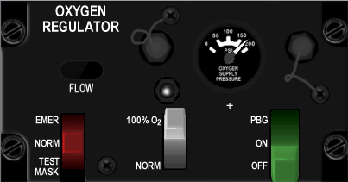

Switch Name | # of poles | Switch type | Positions | Postion names
Flow control (red) | 3 | lever | on-on-on | Test mask, norm, Emer
Oxygen content (green) | 2 | lever | on-on | Norm, 100% O2
Pressure control (grey) | 3 | lever | off-on-on | off, on, PBG

DTU

Build Status
Panel Purchased
Back Panel Purchased
Mounted in Pit
Wired
Knobs mounted
Inputs Tested
Outputs Tested

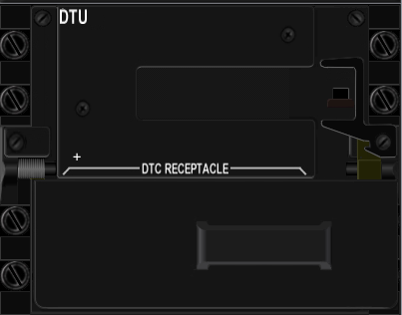

Switch Name | # of poles | Switch type | Positions
DTU | 2 | toggle | off-on

Left MFD

Build Status
Panel Purchased
Back Panel Purchased
Mounted in Pit
Wired
Knobs mounted
Inputs Tested
Outputs Tested

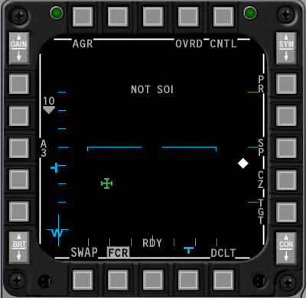

Switch Name | # of poles | Switch type | Positions | Notes | Callback
OSB1 | 2 | push | off-(on) |  | SimCBEOSB_1L
OSB2 | 2 | push | off-(on) |  | SimCBEOSB_2L
OSB3 | 2 | push | off-(on) |  | SimCBEOSB_3L
OSB4 | 2 | push | off-(on) |  | SimCBEOSB_4L
OSB5 | 2 | push | off-(on) |  | SimCBEOSB_5L
OSB6 | 2 | push | off-(on) |  | SimCBEOSB_6L
OSB7 | 2 | push | off-(on) |  | SimCBEOSB_7L
OSB8 | 2 | push | off-(on) |  | SimCBEOSB_8L
OSB9 | 2 | push | off-(on) |  | SimCBEOSB_9L
OSB10 | 2 | push | off-(on) |  | SimCBEOSB_10L
OSB11 | 2 | push | off-(on) |  | SimCBEOSB_11L
OSB12 | 2 | push | off-(on) |  | SimCBEOSB_12L
OSB13 | 2 | push | off-(on) |  | SimCBEOSB_13L
OSB14 | 2 | push | off-(on) |  | SimCBEOSB_14L
OSB15 | 2 | push | off-(on) |  | SimCBEOSB_15L
OSB16 | 2 | push | off-(on) |  | SimCBEOSB_16L
OSB17 | 2 | push | off-(on) |  | SimCBEOSB_17L
OSB18 | 2 | push | off-(on) |  | SimCBEOSB_18L
OSB19 | 2 | push | off-(on) |  | SimCBEOSB_19L
OSB20 | 2 | push | off-(on) |  | SimCBEOSB_20L
 |  |  |  |  | SimCBEOSB_GAINUP_L
30 |  |  |  |  | SimCBEOSB_GAINDOWN_L

Right MFD

Build Status
Panel Purchased
Back Panel Purchased
Mounted in Pit
Wired
Knobs mounted
Inputs Tested
Outputs Tested

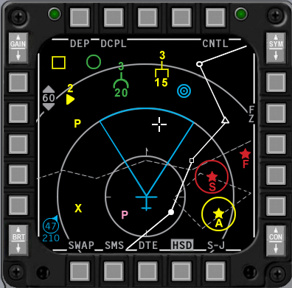

Switch Name | # of poles | Switch type | Positions | Notes | Callback
OSB1 | 2 | push | off-(on) |  | SimCBEOSB_1R
OSB2 | 2 | push | off-(on) |  | SimCBEOSB_2R
OSB3 | 2 | push | off-(on) |  | SimCBEOSB_3R
OSB4 | 2 | push | off-(on) |  | SimCBEOSB_4R
OSB5 | 2 | push | off-(on) |  | SimCBEOSB_5R
OSB6 | 2 | push | off-(on) |  | SimCBEOSB_6R
OSB7 | 2 | push | off-(on) |  | SimCBEOSB_7R
OSB8 | 2 | push | off-(on) |  | SimCBEOSB_8R
OSB9 | 2 | push | off-(on) |  | SimCBEOSB_9R
OSB10 | 2 | push | off-(on) |  | SimCBEOSB_10R
OSB11 | 2 | push | off-(on) |  | SimCBEOSB_11R
OSB12 | 2 | push | off-(on) |  | SimCBEOSB_12R
OSB13 | 2 | push | off-(on) |  | SimCBEOSB_13R
OSB14 | 2 | push | off-(on) |  | SimCBEOSB_14R
OSB15 | 2 | push | off-(on) |  | SimCBEOSB_15R
OSB16 | 2 | push | off-(on) |  | SimCBEOSB_16R
OSB17 | 2 | push | off-(on) |  | SimCBEOSB_17R
OSB18 | 2 | push | off-(on) |  | SimCBEOSB_18R
OSB19 | 2 | push | off-(on) |  | SimCBEOSB_19R
OSB20 | 2 | push | off-(on) |  | SimCBEOSB_20R
 |  |  |  |  | SimCBEOSB_GAINUP_R
 |  |  |  |  | SimCBEOSB_GAINDOWN_R

Other
Build Status
Panel Purchased
Back Panel Purchased
Mounted in Pit
Wired
Knobs mounted
Inputs Tested
Outputs Tested

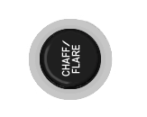

Switch Name | # of poles | Switch type | Positions | Postion names | Notes | Callback
Chaff/flare button
Alt gear | 2 |  |  |  | ? | AFAlternateGear, AFAlternateGearReset
Canopy switch | 2 |  |  |  |  | AFCanopyToggle
pedal adj | 0 | T handle | mechanical | none
Mark beacon | 0 | green indicator light | none | mrk bcn

ACES-II

Build Status
Panel Purchased
Back Panel Purchased
Mounted in Pit
Wired
Knobs mounted
Inputs Tested
Outputs Tested

Switch Name | # of poles | Positions | Postion names | Notes | Callback
Eject grip | 2 |  |  |  | SimEject
Safety Lever | 2 |  |  |  | SimSeatOff, SimSeatOn
Manual release

 | J15
1 | BKLGT-V
2 | BKLGT+V
3 | +12V LEFT
4 | +28V LEFT
5 | GND LEFT
6 | EJECT
7 | SEAT_ON
8 | 8 OPEN,
9 | 9 OPEN,
10 | 10 OPEN

TQS

Switch Name | # of poles | Switch type | Positions | Postion names | Notes | Callback
DOGFIGHT | 3 |  | on-off-on | DDOGFIGHT, , |  | SimSelectMRMOverride, SimDeselectOverride, SimSelectSRMOverride
MAN RNG/UNCAGE |  | Rotary knob |  | MAN RNG/UNCAGE |  | BMS alanog axis or SimRangeKnobDown, SimRangeKnobUp
ANT ELEV |  | Rotary knob | Detented center |  |  | BMS alanog axis or SimRadarElevationDown, SimRadarElevationCenter, SimRadarElevationUp
CURSOR |  | Joystick |  |  |  | BMS alanog axes or SimCursorDown ,SimCursorLeft ,SimCursorRight , SimCursorUp
ENABLE | 2 | push | off-(on) |  |  | SimCursorEnable
Speed Brake | 2 |  |  |  |  | AFBrakesIn, AFBrakesOut
PTT | 4 |  |  | VHF,UHF,IFF IN,IFF OUT |  | SimTransmitCom2,SimTransmitCom1
Black-Out Switch | 2

SSCG

Switch Name | # of poles | Switch type | Positions | Postion names | Notes | Callback
NWS-A/R DISC-MSL STEP | 2 |  | off,(on) |  |  | SimMissileStep
Trim | 5 |  |  | Off,Fwd,Aft,Left,Right |  | AFElevatorTrimUp, AFElevatorTrimDown ,AFAileronTrimLeft, AFAileronTrimRight
Display Manag | 5 |  |  | Off,Fwd,Aft,Left,Right |  | SimDMSUp, SimDMSDown, SimDMSLeft,SimDMSRight
Weapon Release | 2 |  | off,(on) |  |  | SimPickle
Paddle Switch | 2 |  |  |  |  | SimAPOverride
Trigger | 3 |  |  | Off,Detent1,Detent2 |  | SimTriggerFirstDetent, SimTriggerSecondDetent
Pinky Switch | 2 |  |  |  |  | SimPinkySwitch
TMS | 5 |  |  | Off,Fwd,Aft,Left,Right |  | SimTMSUp,SimTMSDown, SimTMSLeft,SimTMSRight
CMS | 5 |  |  | Off,Fwd,Aft,Left,Right |  | SimDropProgrammed, SimECMConsent, ,SimECMStandby

Switch Mapping for non-Falcon

Test
 | Lomac | Postion names | Keystroke
EPU gen |  | off-epu gen
PROBE HEAT |  | test-off-probe heat
FIRE & OHEAT DETECT |  | n/a
OXY |  | off-QTY
MAL & IND LTS |  | n/a
A B C D
test maint |  | h

Anti-G
Switch Name | Lomac | Postion names | Keystroke
Test |  | Test

Flt control
Switch Name | Lomac | Postion names | Keystroke
DIGITAL |  | off-backup
ALT FALPS | Flaps Up | norm | LCtrl-F
 | Flaps Landing Position | extend | LShift-F
MANUAL TF FLYUP |  | disable-enable
LE FLAPS |  | auto-lock
FLCS |  | reset-off
BIT / OFF |  | OFF, BIT
RUN FAIL

Manual Trim
Switch Name | Lomac | Position names | Keystroke
Pitch Trim
Roll Trim
Yaw Trim
Trim /AP DISC |  | norm, disc

Fuel
Switch Name | Lomac | Position names | Key Strokes
MASTER | Engines Stop | OFF | RShift-End
 |  | MASTER
TANK INERTING | Fuel Dump | OFF-TANK INERTING | R
ENG FEED |  | OFF, NORM, AFT, FWD
AIR REFUEL | Refueling Bay | CLOSE, | LCtrl-R
 |  | OPEN | LCtrl-R

Aux Comm
Switch Name | Lomac | Position names | Keystroke
MASTER |  | off, STBY, LOW, NORM, EMER
M-4 CODE |  | hold, a/b, zero
CNI |  | BACK UP, UFC
REPLY |  | OUT, A, B
MONITOR |  | OUT, AUDIO
TACAN |  | A/A TR-REC-T/R
CHANNEL 100's |  | 0-9 inclusive
CHANNEL 10's |  | 0-9 inclusive
CHANNEL 1's |  | 0-9 inclusive
channel x/y |  | x, y

Ext Lighting
Switch Name | Lomac | Position names | Keystrokes
Form
Master | Illumination Cockpit | off | L
 |  | norm | L
Aerial Refueling
Anti Collision | Navigation lights | Off | RCtrl-L
 |  | anti collision | RCtrl-L
Flash Steady |  | flash, steady
Wing Trail | Smoke | dim, off, brt | T
 |  | off | T
 |  | brt | T
Fuselage |  | dim, off, brt

EPU
Switch Name | Lomac | Position names | Keystroke
EPU | 3 | OFF-NORMAL-ON | Center guard on NORMAL
RUN light | 0 | green light
HYDRAZN-AIR | 0 | HYDRAZN-AIR

Elect
Switch Name | Lomac | Position names | Keystrokes
MAIN PWR | Power Switch | OFF | Shift-P
 |  | BAT | Shift-P
 |  | MAIN PWR | Shift-P
CAUTION RESET
FLCS PMG-MAIN GEN |  | FLCS PMG-MAIN GEN
STBY GEN |  | STBY GEN
EPU GEN-EPU / PMG |  | EPU GEN-EPU / PMG
FAIL |  | FAIL
TO FLCS-FLCS RLY |  | TO FLCS-FLCS RLY

AVTR
Switch Name | Lomac | Position names | Keystroke
AVTR |  | on, auto, off

ECM
Switch Name | Lomac | Position names | Keystroke
OPR |  | OFF-STBY-OPR
DIM |  | 1, 2, 3
XMIT |  | xmit, blank
RESET |  | reset, blank
BIT |  | bit, blank
1 |  | S, A, F, T light in corners
2 |  | S, A, F, T light in corners
3 |  | S, A, F, T light in corners
4 |  | S, A, F, T light in corners
5 |  | S, A, F, T light in corners
ALT |  | S, A, F, T light in corners
FRM |  | S, A, F, T light in corners
SPL |  | S, A, F, T light in corners

Jet Start
Switch Name | Lomac | Position names | Keystroke
JET FUEL | Engines Start | START2-OFF-START1 | RShift-Home
ENG CONT |  | SEC-PRI
AB RESET |  | ENG DATA-NORM-AB DATA
MAX POWER |  | OFF-MAX POWER
RUN |  | green light

Audio2
Switch Name | Lomac | Position names | Keystroke
INTERCOM
TACAN
ILS
HOT MIC |  | CIPHER, OFF, HOT MIC

Audio
Switch Name | Lomac | Position names | Keystroke
COMM 1 volume
COMM 1 selector |  | OFF-SQL-GD
COMM 2 volume
COMM 2 selector |  | OFF-SQL-GD
SECURE VOICE
TF
MSL | 0
THREAT | 0

UHF
Switch Name | Lomac | Position names | Keystroke
UHF |  | OFF-MAIN-BOTH-ADF
TONE |  | tone
VOL
SQUELCH |  | OFF-ON
MANUAL |  | MANUAL-PRESET-GUARD
Freq 100's |  | A, 3, 2, T
Freq 10's |  | 0-9 inclusive
Freq 1's |  | 0-9 inclusive
Freq 1/10's |  | 0-9 inclusive
Freq 1/1000's |  | 00, 25, 50, 75
CHAN |  | 1-19 inclusive
EMB |  | ??

Manual Pitch
Switch Name | Lomac | Position names | Keystroke
MANUAL PITCH |  | OVRD-NORM

Threat Warn Aux
Switch Name | Lomac | Position names | Keystroke
Search |  | search
activity power |  | activity power
Low priority |  | low
system power |  | power
fuse |  | n/a
Dimmer |  | n/a

CMDS
Switch Name | Lomac | Position names | Keystroke
RWR |  | off, on
JMR |  | off, on
MWS |  | off, on
01 |  | off, on
02 |  | off, on
CH |  | off, on
FL |  | off, on
JETT |  | off, JETT
PRGM |  | bit, 1, 2, 3, 4, 5
MODE |  | off, stby, man, semi, auto, byp
STATUS NO GO |  | NO GO (green lit legend)
STATUS GO | 0 | GO (green lit legend)
STATUS READY | 0

Gear Panel
Switch Name | Lomac | Position names | Keystrokes
Emergency jettison | Weapons Jettison |  | LCtrl-W
wheel lights
Hook | Toggle Arrestor Hook |  | Ctl-G
Ground jettison
Brakes
Parking brake |  | off
 | Wheel Brake on | anti skid | W
 | Wheel Brake on | brake | W
Stores |  | cat III, cat I
Horn silencer | Audible Warning Reset | n/a | RShift-N
Landing lights | Gear Light Near/Far/Off | taxi | RAlt-L
 | Gear Light Near/Far/Off | off | RAlt-L
 | Gear Light Near/Far/Off | landing | RAlt-L
Down lock release |  | n/a
Gear down enable |  | n/a
Gear handle | Landing Gear Down | Down | LShift-G
 | Landing Gear Up | Up | LCtrl-G
Gear warning light |  | n/a

MISC
Switch Name | Lomac | Position names | Keystrokes
RF quiet | Radar On/Off | silent | I
 |  | rf norm | I
ECM light |  | n/a
Laser arm |  | off, arm
Alternate release | Weapon Fire | n/a | Space
Master arm |  | simulate, off, arm
ADV mode |  | active/standby
Autopilot pitch |  | att hold, a-p off, alt hold
Autopilot roll |  | strg sel, att hold, hdg sel

Threat Warn Prime
Switch Name | Lomac | Positions | Notes
Handoff |  | off-(on)
Priority |  | off-(on)
Target separate |  | off-(on)
Missile Launch |  | none
system test |  | off-(on)
Unknown/naval |  | off-(on)

Eyebrow Lights L
Switch Name | Lomac | Position names | Keystrokes
IFF |  | IFF IDENT
Blank 1 |  | (directly above IFF button)
Blank 2 |  | (directly below TF-FAIL button)
TF fail |  | TF-FAIL
F-ACK |  | F-ACK | RShift-N
Master Caution |  | Master Caution push to reset | RShift-N

Eyebrow Lights R
Switch Name | Lomac | Position names | Keystroke
Right
Engine fire |  | ENGFIRE ENGINE
Fluid pressure warning |  | HYD/OIL PRESS
Flight controls warning |  | FLCS DBU ON
Landing configuration |  | TO/LDG CONFIG
Canopy seal warning |  | CANOPY

Indexer L

Switch Name | Lomac | Position names | Keystrok
Left Indexer

Indexer R

Switch Name | Lomac | Position names | Keystroke
Right Indexer

ICP
Switch Name | Lomac | Position names | Keystroke
COM1 |  | n/a
COM2 |  | n/a
IFF |  | n/a
LIST |  | n/a
A-A |  | n/a
A-G |  | n/a
1 key |  | n/a
2 key |  | n/a
3 key |  | n/a
Recall key |  | n/a
4 key |  | n/a
5 key |  | n/a
6 key |  | n/a
enter key |  | n/a
7 key |  | n/a
8 key |  | n/a
9 key |  | n/a
0 key |  | n/a
WX |  | n/a
ICP inc/dec |  | down arrow, up arrow
display control switch |  | down, rtn, up, seq (cw from bottom) | ?
Drift cutoff |  | warn reset, norm, drift c/o
FLIR up/down |  | down arrow, up arrow
FLIR gain |  | auto, lvl, gain
SYM |  | off
BRT
RET DEPR
CONT

INSTR

Switch Name | Lomac | Postion names | Keystroke
mode |  | ils/tcn, tcn, nav, ils/nav
heading |  | n/a

HIS – Not used
Switch Name | Lomac | Postion names | Keystroke
course |  | n/a
heading |  | n/a

Fuel Qty Select
Switch Name | Lomac | Postion names | Keystroke
source |  | ext ctr, ext wing, int wing, rsvr, norm, test
Fuel transfer |  | wing first, norm

Sensor Power
Switch Name | Lomac | Postion names | Keystroke
Left hardpoint |  | off, left hdpt
Right hardpoint |  | off, right hdpt
Fire control radar |  | off, fcr
Radar altimeter |  | off, stby, rdr alt

HUD Control
Switch Name | Lomac | Postion names | Keystrokes
Velocity scales |  | off, vah, vv/vah
Attitude scales |  | off, fpm, att/fpm
Data Entry |  | off, pfl, ded data
DEPR reticle |  | off, pri, stby
Velocity |  | gnd spd, tas, cas
Altitude |  | auto, baro, alt radar
Brightness | HUD Colour | night | RCtrl-H
 |  | auto | RCtrl-H
 |  | day | RCtrl-H
Test |  | off, on, test step

Nuclear consent
Switch Name | Lomac | Positions | Keystroke
plain |  | off-on
arm |  | on-off-on

Lighting
Switch Name | Lomac | Positions | Keystroke
Consoles (primary) |  | increase clockwise
instrument panel (primary) |  | increase clockwise
Data entry display (primary) |  | increase clockwise
Consoles (flood) |  | increase clockwise
instrument panel (flood) |  | increase clockwise
malfunction lights |  | off-on

Master Zeroize

Switch Name | Lomac | Postion names | Keystroke
voice message |  | inhibit, voice message
zeroize |  | data zeroize, blank, master zeroize

Air Cond
Switch Name | Lomac | Postion names | Keystroke
air source |  | off, norm, dump, ram
temp

KY-58
Switch Name | Lomac | Postion names | Keystroke
mode |  | p, c, ld, rv
volume
number rotary |  | 215, 1, 2, 3, 4, 5, 6, 7 all
on/off rotary |  | off, on, TD

Avionics Power
Switch Name | Lomac | Postion names | Keystroke
FCC |  | off, FCC
SMS |  | off, SMS
MFD |  | off, MFD
UFC |  | off, UFC
INS |  | off, stor hdg, norm, nav, cal, in flt align, att
GPS |  | off, GPS
DL |  | off, DL
MAP |  | off, MAP

Anti-Ice
Switch Name | Lomac | Postion names | Keystroke
engine anti ice |  | off, auto, on
IFF antenna select |  | lower, norm, upper
UHF antenna select |  | lower, norm, upper

Oxy Reg
Switch Name | Lomac | Postion names | Keystroke
Flow control (red) | 3 | Test mask, norm, Emer
Oxygen content (green) | 2 | Norm, 100% O2
Pressure control (grey) | 3 | off, on, PBG

DTU
Switch Name | Lomac | Positions | Keystroke
DTU |  | off-on

Left MFD
Switch Name | Lomac | Positions | Keystroke
OSB1 |  | off-(on)
OSB2 |  | off-(on)
OSB3 |  | off-(on)
OSB4 |  | off-(on)
OSB5 |  | off-(on)
OSB6 |  | off-(on)
OSB7 |  | off-(on)
OSB8 |  | off-(on)
OSB9 |  | off-(on)
OSB10 |  | off-(on)
OSB11 |  | off-(on)
OSB12 |  | off-(on)
OSB13 |  | off-(on)
OSB14 |  | off-(on)
OSB15 |  | off-(on)
OSB16 |  | off-(on)
OSB17 |  | off-(on)
OSB18 |  | off-(on)
OSB19 |  | off-(on)
OSB20 |  | off-(on)

Right MFD
Switch Name | Lomac | Positions | Keystroke
OSB1 |  | off-(on)
OSB2 |  | off-(on)
OSB3 |  | off-(on)
OSB4 |  | off-(on)
OSB5 |  | off-(on)
OSB6 |  | off-(on)
OSB7 |  | off-(on)
OSB8 |  | off-(on)
OSB9 |  | off-(on)
OSB10 |  | off-(on)
OSB11 |  | off-(on)
OSB12 |  | off-(on)
OSB13 |  | off-(on)
OSB14 |  | off-(on)
OSB15 |  | off-(on)
OSB16 |  | off-(on)
OSB17 |  | off-(on)
OSB18 |  | off-(on)
OSB19 |  | off-(on)
OSB20 |  | off-(on)

Other
Switch Name | Lomac | Positions | Keystrokes
Chaff/flare button
Alt gear
Canopy switch | Canopy Open/Close | Open | LCtrl-C
 | Canopy Open/Close | Close | LCtrl-C
pedal adj
Mark beacon

ACES-II
Switch Name | Lomac | Positions | Keystrokes
Eject grip | Eject |  | LCtrl-E (3 times)
Safety Lever
Manual release

TQS

Switch Name | Lomac | Postion names | Keystroke
DOGFIGHT |  | DDOGFIGHT, ,
MAN RNG/UNCAGE |  | MAN RNG/UNCAGE
ANT ELEV
CURSOR
ENABLE
Speed Brake
PTT |  | VHF,UHF,IFF IN,IFF OUT
Black-Out Switch

SSCG
Switch Name | Lomac | Postion names | Keystroke
NWS-A/R DISC-MSL STEP
Trim |  | Off,Fwd,Aft,Left,Right
Display Manag |  | Off,Fwd,Aft,Left,Right
Weapon Release
Paddle Switch
Trigger |  | Off,Detent1,Detent2
Pinky Switch
TMS |  | Off,Fwd,Aft,Left,Right
CMS |  | Off,Fwd,Aft,Left,Right

